LABORATORY CHAPTER №14

TOPIC. DEVELOPMENT OF STRUCTURE AND THE MAINTENANCE OF A LESSON IN THE ENVIRONMENT OF REMOTE LEARNING.

Information technology is the most important component of the process of using the information resources of society. In modern society, the main technical means of information processing technology is a personal computer, which has significantly influenced both the concept of building and using technological processes, and the quality of the resulting information. The introduction of a personal computer into the information sphere and the use of telecommunication means of communication determined a new stage in the development of information technology.
Information technology is a useful tool that is successfully used in many areas of society. Medicine is no exception. Progress in information technologies had a positive effect on the development of new areas of organization of medical care for the population. The possibility of conducting consultations for patients, observation and control in real time, the use of systems that allow remotely recording and transmitting physiological parameters - all this takes medicine to a qualitatively new level. Many developed countries are already actively applying the above and many other systems in regular practice in the health sector.
The main direction of the impact of information and communication technologies (ICT) on society is the impact on the structure of the national economy, state policy, culture, science and education. As a result, a new communication economy is being formed, in which knowledge and information become the main resource for development. In this regard, it seems fair to characterize the appropriate communicative economy a new type of society as an information society.
Constituting the basis of a “new economy”, “knowledge economy” or a communication economy, ICT has a fundamental impact on the development of the entire national economy, and this effect has common features and essential features compared to the impact of traditional technologies on the structure and growth of the economy.
The impact of ICT on the development of the national economy goes through the same stages as the main technologies. Initially, the contribution of new technologies to economic growth is determined by the qualitative improvement of the means of production, changes in traditional technologies, which leads to an increase in the organic composition of capital, an increase in labor productivity and the formation of the effect of reorganization and improvement of production processes. At the next stage, the result of their influence on financial markets begins to manifest itself. At the third stage, there are factors that contribute to the rapid spread of new technologies, under the influence of which active changes occur in all sectors of the economy. At this stage, the increase in the efficiency of use of new technologies is primarily due to a significant reduction in costs.
At the same time, ICT in comparison with the previous traditional technologies differ in a number of features, due to which their influence on the economic growth and development of the national economy is of a qualitatively different nature. First of all, it is the global nature of the spread of ICT - they are used in almost all sectors where productivity and efficiency can be improved, including in the area of ​​governance. The high rate of development of ICT is associated with extremely low marginal costs of their distribution and use, which is reflected in a significant reduction in prices for ICT industry products. Due to this, the total effect from the use of new technologies in the economy can be obtained much faster and to a greater extent than from any other traditional technologies. ICTs provide a special economic effect, since they are associated with the processing and exchange of information, which plays a primary role in the modern economy.
At present, rapidly developing new computer technology and the Internet, and in a place with them and develop new ways of learning, one such technology is distance education, in particular, the most popular learning through Internet technologies. Thanks to the development of the Internet and modern methods of communication and exchange of data, it is possible to create and apply learning new ways of learning, such as electronic notes, encyclopedias, tests, glossaries, profiles, virtual laboratories, etc. One of the options for using these methods and techniques is Moodle package - which is a content management system, specifically designed to create quality online-courses teachers.
Moodle is a free and open-source software learning management system written in PHP and distributed under the GNU General Public License. Developed on pedagogical principles, Moodle is used for blended learning, distance education, flipped classroom and other e-learning projects in schools, universities, workplaces and other sectors.
With customizable management features, it is used to create private websites with online courses for educators and trainers to achieve learning goals. Moodle (acronym for modular object-oriented dynamic learning environment) allows for extending and tailoring learning environments using community sourced plugins.

Step 1 - Loading Moodle and obtaining Administrator rights

- Navigate to C:\MoodleWindowsInstaller-latest-31\
- Click on icon “Start MOODLE”

NOTE: IF you will see such error message click OK twice.
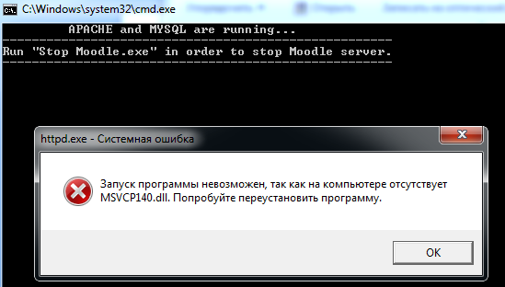

- After that you will get message about successful start of Apache and Mysql servers start your browser.

- Open your web browser (Moodle works with Internet Explorer, Firefox, Chrome or Safari).

NOTE: Do not close prompt (console) window while you are working with Moodle servers.

- Type this address into your browser’s address bar: localhost.
- Now you will see the Moodle start page.
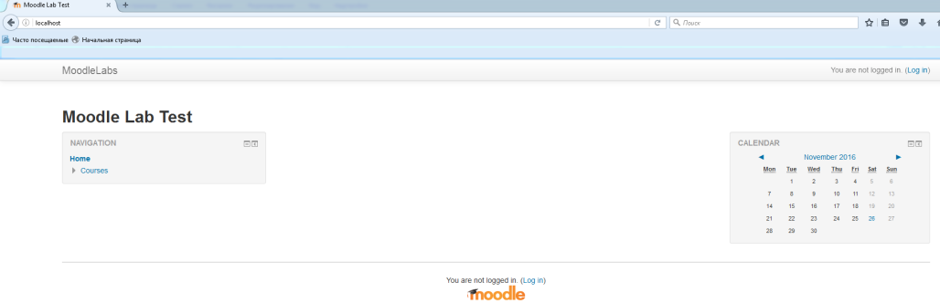

- To get access to your Moodle site you have to Log in with following:
Login: admin215
Password: Admin215!

NOTE: You have signed as an common Moodle course site admin. And now you have to create your own site as an administrator. To do that, firstly you have to create your own admin account.

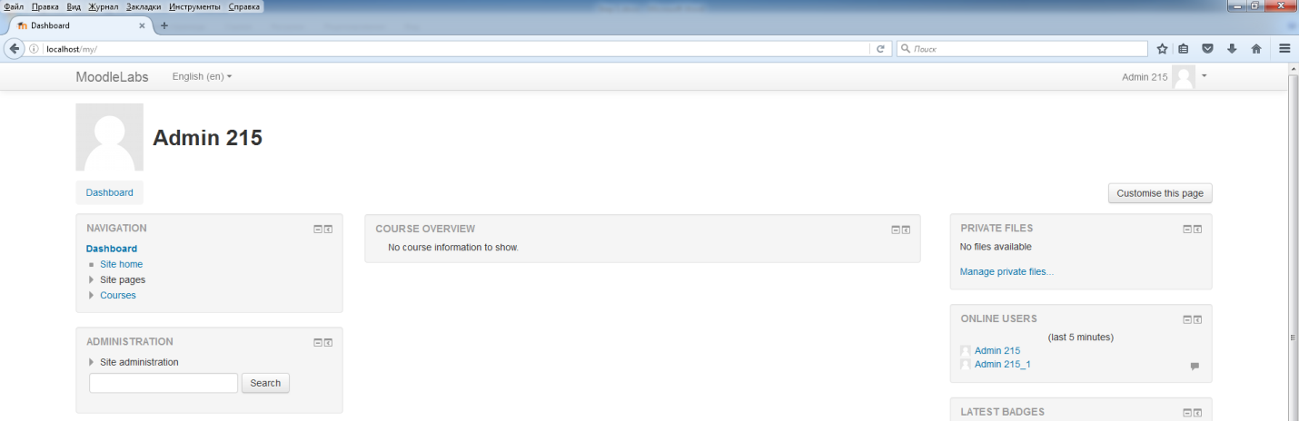
- Go to Administration Menu and choose Users
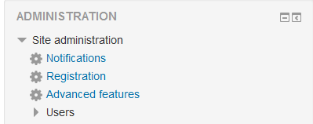
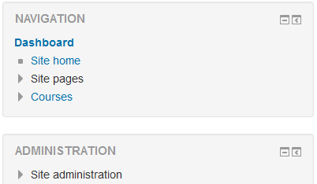

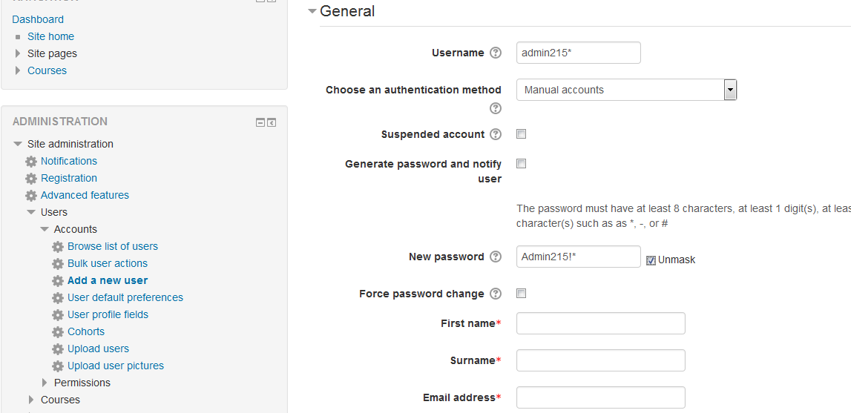
- Select Accounts -> Add new user. On the right you will see registration field of new Moodle user.

- Fill in fields with your data. You have to use following info in the fields:
Username: admin215*
New password: Admin215!*
NOTE: replace * - with your number (1-30).
You have to fill also fields: First name, Surname, Email address, City, Country.
- Check your account on the users list.
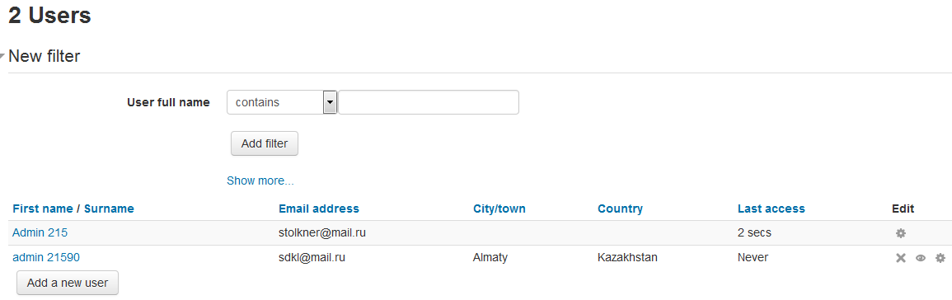
- Now open Permissions section to get administration permission. You have to complete this step to get possibility to create and change new Moodle courses.
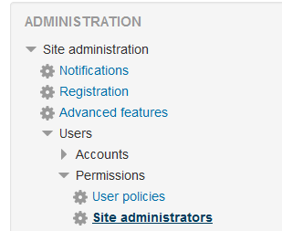
On the Manage site administrators screen displayed list of currently registries users, and current site administrators.
You have to check your account on the right screen Users and press <-ADD button to add you like admin of the site.
Press Continue when question appear “Do you really want to add user admin 215* (admin215*, *@*) as new site administrator?

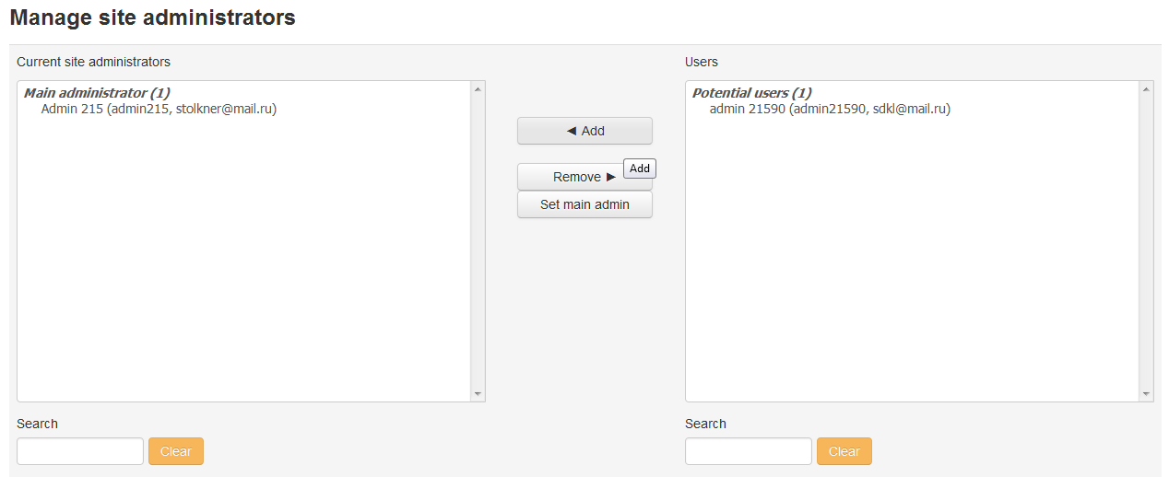

- Now you have to log out from main admin account and Log In into yours just created.
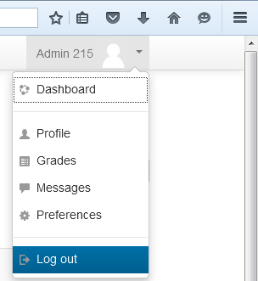

Step 2 – Creating your own course
Courses in the Moodle system is in a hierarchical structure of categories
Any e-course should be in a certain category. Only the administrator has the ability to create categories and course creator (teacher) may create courses in a particular category.
Now you have to create your own category and course.
- Go to Administration -> Site administration -> Courses -> Manage Courses and categories.
On the Course and category management section displayed all current courses and herein you can manage with them.
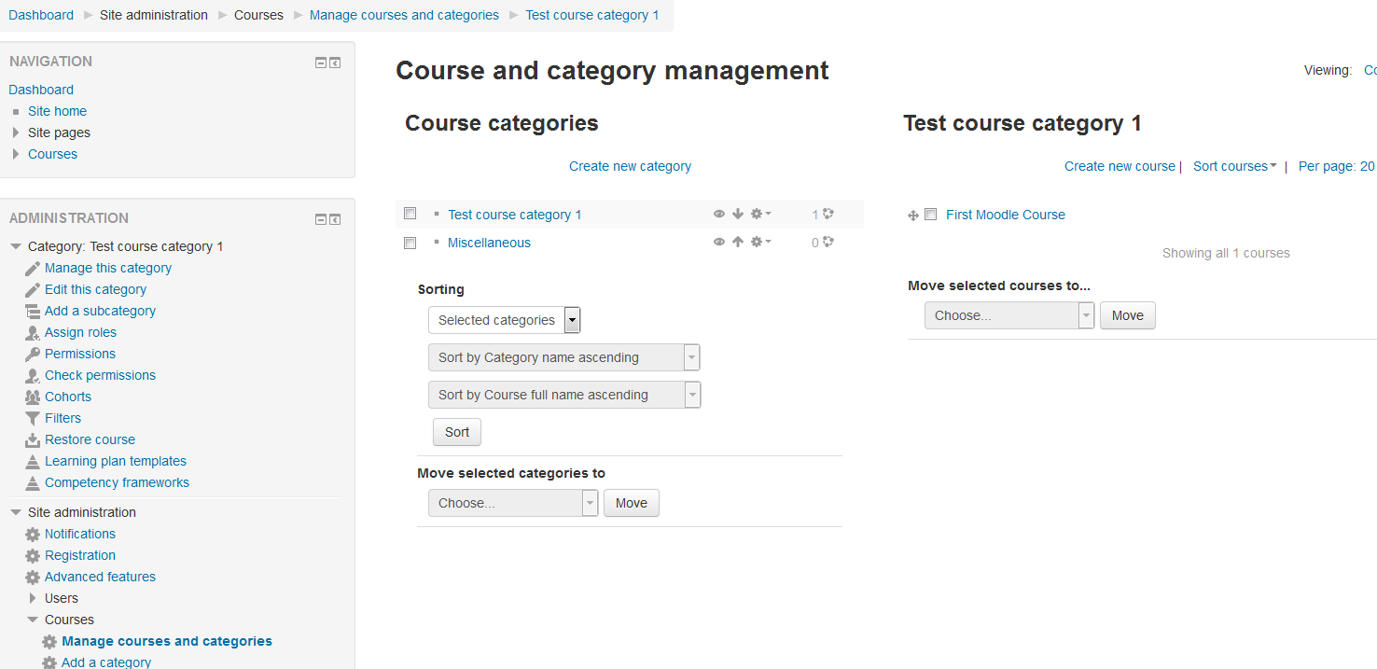
- To create new course’s category select Create new category. That will open new category window.
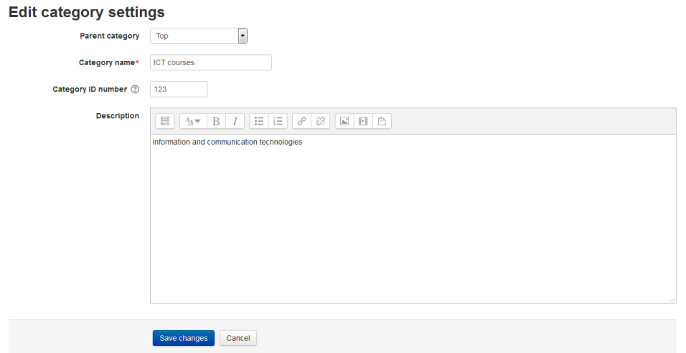
Select one of course categories from the list if you creating children course or select Top.
Give some name, description and ID of the Category.
After filling fields pres create category.
Now your newly created category is in the Course categories list.
- Now press create new course under Courses section. You will get to course creation window.

In the General section fill in all fields about your course. Add some short description.
- Open Course format section. Herein you can indicate type of your course. Star aand end dates, duration, appearance format on site.

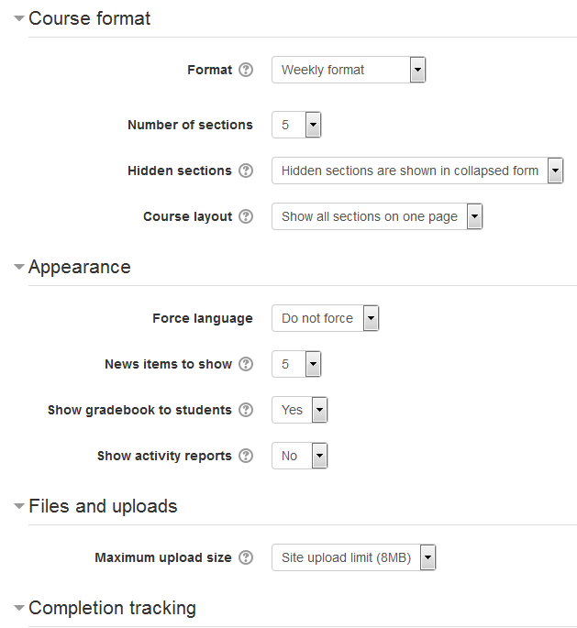

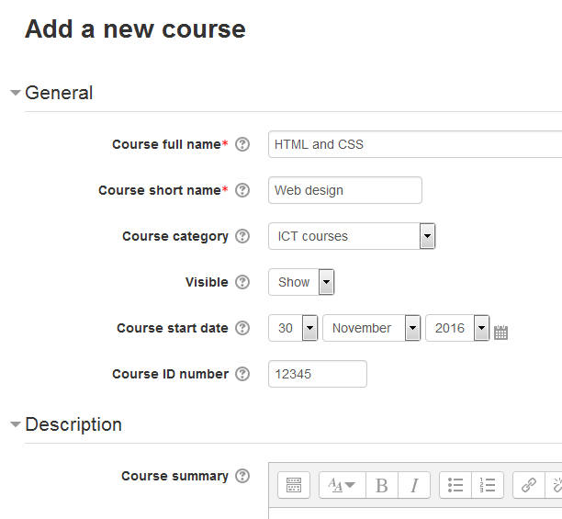

- The format calendar (weekly format). This format is defined by the start date of the course and the number of weeks during which he will be taught. The system creates a separate section for each week of the course. In each section you can add resources, forums, quizzes, and other course materials. This format is suitable in the case where all students learn the course materials at the same time, ie, something like this is happening in full-time education.
- Format-structure (thematic format). This format assumes decomposition rate on the topic. When you create a course in this format indicates the number of and the system creates a separate section for each theme. In each section
You can add resources, forums, quizzes, and other course materials. If not for you
principled terms the students mastering of each topic and there is no specific time
graphics, this format is optimal.
- Format Forum (social format). This format is organized in the form of
a kind of bulletin board. It is more suitable for informal
courses, or courses, discussions.

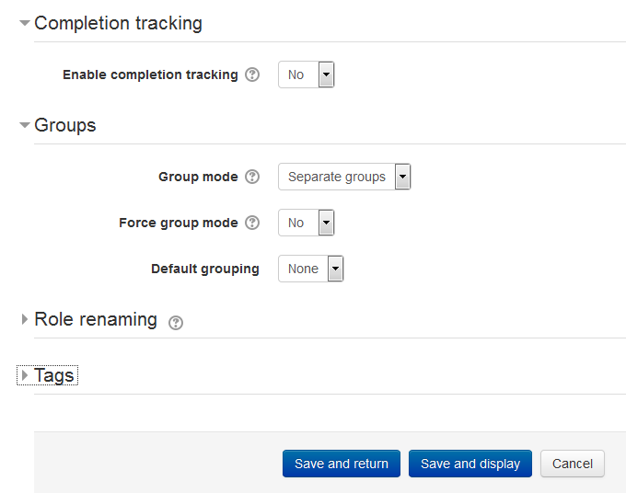

- Fill in other sections with random values. In Appearance section you can select whether
course means specific language and whether students can see theirs grades.
Define maximum file size for uploading in Files and upload section.
On the Group section define whether course means group work or not.
- After filling all sections press save and return. Now you can see your courses under chosen category field.

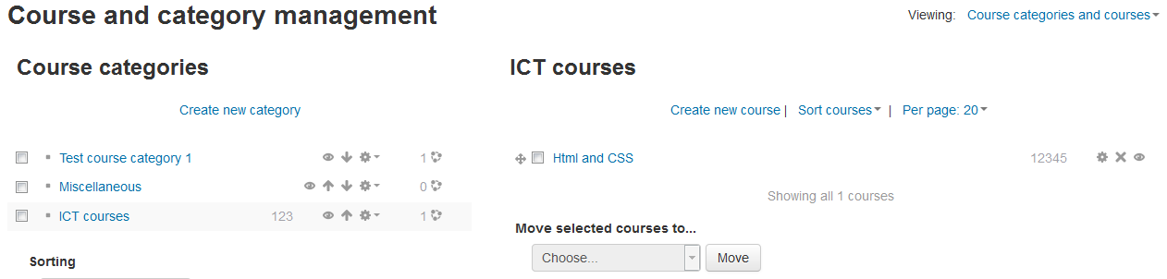

The next time you log in created course will be displayed on the first page in the appropriate category.

Step 3 - Filling course explanations and text pages

- Go to the Courses section in your navigation panel. You will see all categories here.

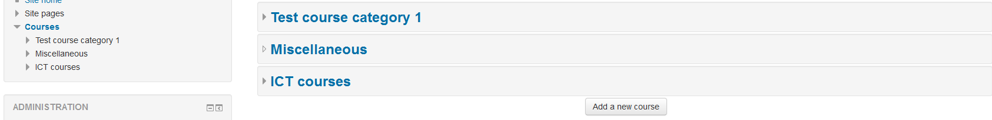

- Open your course by clicking on its category and then on its title.
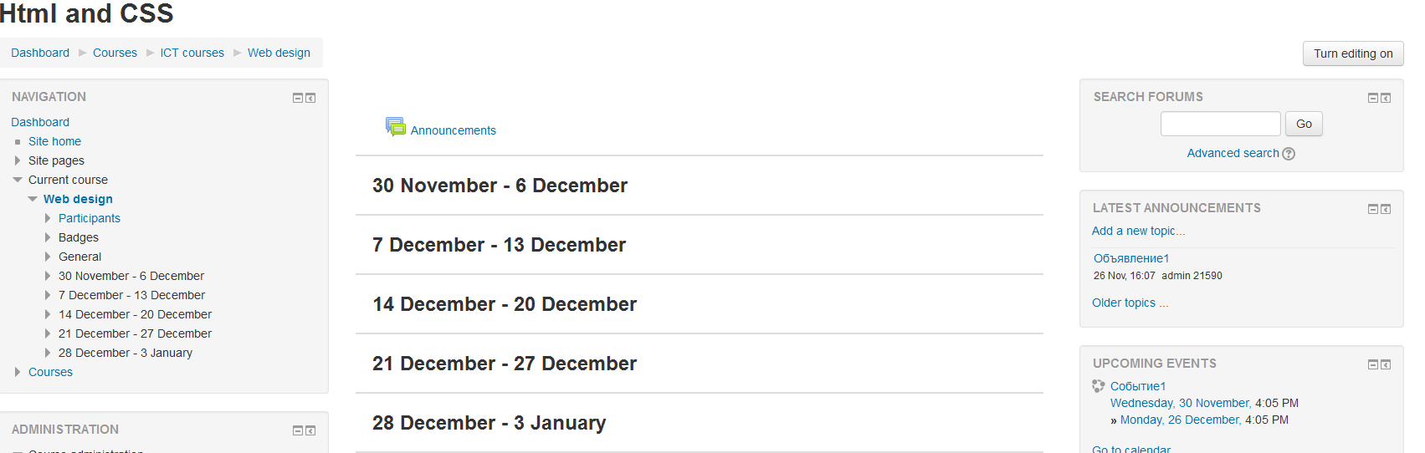

All course material in Moodle system can be displayed by
Resources and Modules. To add or change items or resources you need to switch to edit mode. This can be done by pressing the button in the upper right corner of the main page course or in the edit link in the administrative block Editing can be turned off by pressing the button or link (renamed "Finish editing).
- Click on Turn editing on to add course materials. In editing mode you can add materials, move block an change dimensions of site elements.
